**EVEREST ENGINEERING COLLEGE**

  **SANEPA, LALITPUR**

(AFFILIATED TO POKHARA UNIVERSITY)

AN

LAB REPORT

ON

**Object Oriented Programming In C++**

***[Object As An Function Argument]***

**Lab Sheet: 3**



**SUBMITTED BY SUBMITTED TO**

Name:-**SAKCHYAM ACHARYA** Er.Pradip Paudel

Roll No:-40 Everest Engineering College

Department of Computer Engineering

Faculty:-BE CMP

Year/Semester: - 2nd SEM

Batch: 2021

Verified By:-

Student's Signature

**Index Page:-**

Topics Page No

* Title, Objective....................................................................................3
* Theory……………………………………………………………………………….3
* Ways of Passing Object:-
* Pass-by-value
* Pass-by-reference
* Questions with Source Code & Output…………………………………………...3-16
* Discussion & Conclusion ...................................................................................16

**Title:- Object As An Function Argument**

**Objective:-**

* To be familiar with how to pass an object as an argument & how to return object.

• To be able to solve problems by passing object as an arguments.

**Theory:-**

**Ways of Passing Object:-**

Objects can be passed into two different ways:-

**1. Pass-by-value:** where a copy of the entire object is passed to the function. Here, any changes made to the formal object parameters do not affect the actual object parameters.

**2. Pass-by-reference:** where only the address of the object is transferred to the function. Here, any changes made to the formal object parameters will be reflected in the actual object parameters also

* **Problems with Source Code & Output:-**

**Problem No:1**

**WAP to find the sum of two complex number by passing object as arguments.**

*Source Code:*

//Wap to find the sum of two complex number by passing object as an argument.

#include<iostream>

using namespace std;

class complex{

private:

int real,imagi;

public:

void inputdata(){

cout<<endl<<"Real Number?:"<<" & "<<"Imaginary Number?:";

cin>>real>>imagi;

}

void addcomplex(complex c1,complex c2){

real=c1.real + c2.real;

imagi=c1.imagi + c2.imagi;

}

void display(){

cout<<real<<"+"<<imagi<<"i"<<endl;

}

};

int main(){

complex c1,c2,c3;

cout<<"For 1st Complex Number"<<endl;

c1.inputdata();

cout<<endl<<"For 2nd Complex Number"<<endl;

c2.inputdata();

c3.addcomplex(c1,c2);

cout<<endl<<"Sum of two complex number="<<endl;

c3.display();

return 0;

}

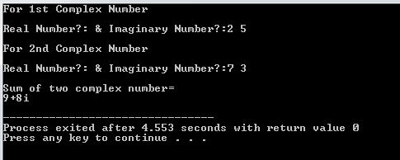

**Problem No:2**

**WAP to find the sum of two complex number by Passing Object as an argument and returning object.**

*Source Code:*

//Passing Object as an argument and returning object.

#include<iostream>

using namespace std;

class complex{

private:

int real,imagi;

public:

void inputcomplex(void);

complex addcomplex(complex c1,complex c2);

void display(void);

};

void complex :: inputcomplex (void){

cout<<"Real Part?:"<<" & "<<"Imaginary Part?:";

cin>>real>>imagi;

}

complex complex :: addcomplex(complex c1, complex c2){

complex ne;

ne.real=c1.real + c2.real;

ne.imagi=c1.imagi + c2.imagi;

return ne;

}

void complex :: display(void){

cout<<real<<"+"<<imagi<<"i"<<endl;

}

int main(){

complex c1,c2,c3,result;

cout<<"For 1st Complex Number"<<endl;

c1.inputcomplex();

cout<<endl<<"For 2nd Complex Number"<<endl;

c2.inputcomplex();

result=c3.addcomplex(c1,c2);

cout<<endl<<"Sum of two complex number="<<endl;

result.display();

return 0;

}

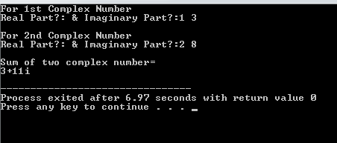

**Problem No:3**

**WAP to find the sum of complex number, function call by one object passing second object as function argument and return third object adding two objects.<<Hint: c3=c1.addcomplex(c2).**

*Source Code:*

#include<iostream>

using namespace std;

class complex{

private:

int real,imagi;

public:

void getinput(){

cout<<"Real Number?:"<<" & "<<"Imaginary Number?:";

cin>>real>>imagi;

}

complex addcomplex(complex c2){

complex ne;

ne.real=real + c2.real;

ne.imagi=imagi + c2.imagi;

return ne;

}

void display(){

cout<<real<<"+"<<imagi<<"i"<<endl;

}

};

int main(){

complex c1,c2,c3;

cout<<"For 1st Complex Number"<<endl;

c1.getinput();

cout<<"For 2nd Complex Number"<<endl;

c2.getinput();

c3=c1.addcomplex(c2);

cout<<"Sum of two complex number="<<endl;

c3.display();

return 0;

}

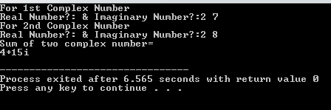

**Problem No:4**

**Perform similar operation in above Ques no: 1, 2, 3 for**

1. **Addition of two times with data members hours, minutes, and second.**
2. **Addition of two height with data members feet and inch.**

**Ques.i**

**4.i.1**

*Source Code:*

// 4.i.a

//Program to add two different time given in hours, minute & second.

//Without Returning value

#include<iostream>

using namespace std;

class time{

private:

int hrs,min,sec;

public:

void gettime();

void addtime(time,time);

void display();

};

void time :: gettime(){

cout<<endl<<"hour?:";

cin>>hrs;

cout<<"minute?:";

cin>>min;

cout<<"second?:";

cin>>sec;

};

void time :: addtime(time t1,time t2){

sec=t1.sec + t2.sec;

min=t1.min + t2.min +(sec/60);

hrs=t1.hrs + t2.hrs + (min/60);

min %=60;

sec %=60;

};

void time :: display(){

cout<<endl<<"Time after addition:"<<endl;

cout<<hrs<<":"<<min<<":"<<sec<<endl;

cout<<"i.e "<<hrs<<" hours "<<","<<min<<" minutes"<<" & "<<sec<<" seconds."<<endl;

};

int main(){

time t1,t2,t3;

cout<<"1st Time"<<endl;

t1.gettime();

cout<<endl<<"2nd Time"<<endl;

t2.gettime();

//add two times

t3.addtime(t1,t2);

t3.display();

return 0;

}

**4.i.2**

*Source Code:*

// 4.i.b

//Program to add two different time given in hours, minute & second.

//With Returning value

#include<iostream>

using namespace std;

class time{

private:

int hrs,min,sec;

public:

void gettime();

time addtime(time t1,time t2);

void display();

};

void time :: gettime(){

cout<<endl<<"hour?:";

cin>>hrs;

cout<<"minute?:";

cin>>min;

cout<<"second?:";

cin>>sec;

};

time time :: addtime(time t1,time t2){

time ne;

ne.sec=t1.sec + t2.sec;

ne.min=t1.min + t2.min +(sec/60);

ne.hrs=t1.hrs + t2.hrs + (min/60);

min %=60;

sec %=60;

return ne;

};

void time :: display(){

cout<<endl<<"Time after addition:"<<endl;

cout<<hrs<<":"<<min<<":"<<sec<<endl;

cout<<"i.e "<<hrs<<" hours "<<","<<min<<" minutes"<<" & "<<sec<<" seconds."<<endl;

};

int main(){

time t1,t2,t3,result;

cout<<"1st Time"<<endl;

t1.gettime();

cout<<endl<<"2nd Time"<<endl;

t2.gettime();

//add two times

result=t3.addtime(t1,t2);

result.display();

return 0;

}

**4.i.3**

*Source Code:*

// 4.i.c

//Program to add two different times given in hours, minute & second.

//Call by one object passing second object as function argument and return third object adding two object.

#include<iostream>

using namespace std;

class time{

private:

int hrs,min,sec;

public:

void gettime();

time addtime(time t2);

void display();

};

void time :: gettime(){

cout<<endl<<"hour?:";

cin>>hrs;

cout<<"minute?:";

cin>>min;

cout<<"second?:";

cin>>sec;

};

time time :: addtime(time t2){

time ne;

ne.sec=sec + t2.sec;

ne.min=min + t2.min +(sec/60);

ne.hrs=hrs + t2.hrs + (min/60);

min %=60;

sec %=60;

return ne;

};

void time :: display(){

cout<<endl<<"Time after addition:"<<endl;

cout<<hrs<<":"<<min<<":"<<sec<<endl;

cout<<"i.e "<<hrs<<" hours "<<","<<min<<" minutes"<<" & "<<sec<<" seconds."<<endl;

};

int main(){

time t1,t2,t3;

cout<<"1st Time"<<endl;

t1.gettime();

cout<<endl<<"2nd Time"<<endl;

t2.gettime();

t3=t1.addtime(t2);

//cout<<"Sum of two time="<<endl;

t3.display();

return 0;

}

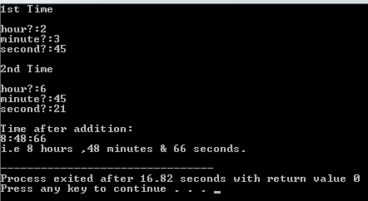

**Ques:ii**

**4.ii.1**

*Source Code:*

//4_ii_a

//Program to add two height given in ft & inch.

//Without Returning value

#include<iostream>

using namespace std;

class height{

private:

int feet,inch;

public:

void getheight(void);

void addheight(height h1,height h2);

void display(void);

};

void height :: getheight(void){

cout<<endl<<"Feet?:";

cin>>feet;

cout<<"Inch?:";

cin>>inch;

};

void height :: addheight(height h1, height h2){

inch=h1.inch + h2.inch;

feet=h1.feet + h2.feet + (inch/12);

inch %=12;

};

void height :: display(void){

cout<<endl<<"Height after addition:-"<<feet<<"."<<inch;

cout<<endl<<"i.e "<<feet<<" ft"<<" & "<<inch<<" inch.";

};

int main(){

height h1,h2,h3;

cout<<" SAK Code"<<endl;

cout<<"1st Height"<<endl;

h1.getheight();

cout<<endl<<"2nd Height"<<endl;

h2.getheight();

h3.addheight(h1,h2);

h3.display();

return 0;

}

**4.ii.2**

*Source Code:*

//4_ii_b

//Program to add two height given in ft & inch.

//with return value.

#include<iostream>

using namespace std;

class height{

private:

int feet,inch;

public:

void getheight(void);

height addheight(height h1,height h2);

void display(void);

};

void height :: getheight(void){

cout<<endl<<"Feet?:";

cin>>feet;

cout<<"Inch?:";

cin>>inch;

};

height height :: addheight(height h1, height h2){

height ne;

ne.inch = h1.inch + h2.inch;

ne.feet = h1.feet + h2.feet + (inch/12);

inch %=12;

return ne;

};

void height :: display(void){

cout<<endl<<"Height after addition:-"<<feet<<"."<<inch;

cout<<endl<<"i.e "<<feet<<" ft"<<" & "<<inch<<" inch.";

};

int main(){

height h1,h2,h3,result;

cout<<" SAK Code"<<endl;

cout<<"1st Height"<<endl;

h1.getheight();

cout<<endl<<"2nd Height"<<endl;

h2.getheight();

result=h3.addheight(h1,h2);

result.display();

return 0;

}

**4.ii.3**

*Source Code:*

//4_ii_c

//Program to add two height given in ft & inch.

//Call by one object passing second object as function argument and return third object adding two object.

#include<iostream>

using namespace std;

class height{

private:

int feet,inch;

public:

void getheight(void);

height addheight(height h2);

void display(void);

};

void height :: getheight(){

cout<<endl<<"Feet?:";

cin>>feet;

cout<<"Inch?:";

cin>>inch;

};

height height :: addheight( height h2){

height temp;

temp.inch=inch + h2.inch;

temp.feet=feet + h2.feet + (inch/12);

temp.inch %=12;

return temp;

};

void height :: display(void){

cout<<endl<<"Height after addition:-"<<feet<<"."<<inch;

cout<<endl<<"i.e "<<feet<<" ft"<<" & "<<inch<<" inch.";

};

int main(){

height h1,h2,h3;

cout<<" SAK Code"<<endl;

cout<<"1st Height"<<endl;

h1.getheight();

cout<<endl<<"2nd Height"<<endl;

h2.getheight();

h3=h1.addheight(h2);

//cout<<"Sum of two time="<<endl;

h3.display();

return 0;

}

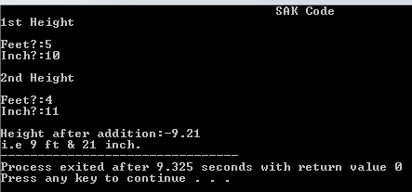

**Problem No:5**

**Create a new class named City that will have two members variable CityName (char[20]),and DistFromKtm (float).Add member functions to set and retrieve the CityName and Distance From Ktm separately.Add a new member function AddDistance that takes two arguments of class city and returns the sum of DistFromKtm of two arguments.In the main function,Initialize three city objects .Set the first and second city to be pokhara and dhangadi.Displat the sum of DistFromKtm of Pokhara and Dhangadi calling AddDistance function of third city object.**

*Source Code:*

#include<iostream>

using namespace std;

class city{

private:

char CityName[20];

float diskp,diskd;

public:

void inputdata1(){

cout<<endl<<"Enter the city name:";

cin>>CityName;

cout<<"Enter the Distance between Kathmandu & entered city in km:";

cin>>diskp;

}

void inputdata2(){

cout<<endl<<"Enter the city name:";

cin>>CityName;

cout<<"Enter the Distance betwwen Kathmandu & entered City:";

cin>>diskd;

}

city adddistance(city d1,city d2){

city ne;

ne.diskp=d1.diskp + d2.diskp;

ne.diskd=d1.diskd + d2.diskd;

return ne;

}

void display(){

cout<<diskp<<"+"<<diskd<<"="<<(diskp+diskd)<<" K.M"<<endl;

}

};

int main(){

city d1,d2,d3,out;

cout<<"\t\tFor Distance between KATHMANDU TO"<<endl;

d1.inputdata1();

cout<<endl<<"\t\tFor Distance between KATHMANDU TO"<<endl;

d2.inputdata2();

out=d3.adddistance(d1,d2);

cout<<endl<<"Sum of two distance(total)=";

out.display();

return 0;

}

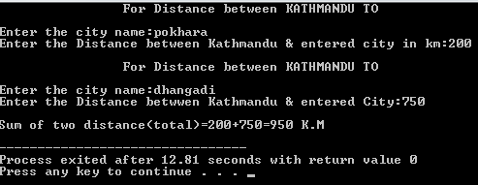

**Problem No:6**

**Create a class called Volume that uses three variables(length,width,height) of type distance (feet and inches) to model the volume of room.Read the three dimensions of the room and calculate the volume it represent, and print out the result.The volume should be in (feet3) form i.e you will have to convert each dimensions into the feet and fraction of for instance,the length 12 feet 6 inches will be 12.5 ft.**

Source Code:

#include<iostream>

using namespace std;

class volume{

private:

float len,wid,hei;

int ft,inch;

public:

void inputdata(){

cout<<endl<<"Enter length in Feet?:";

cin>>ft;

cout<<"Inch?:";

cin>>inch;

len=ft+(inch/12.0);

cout<<endl<<"Enter breadth in Feet?:";

cin>>ft;

cout<<"Inch?:";

cin>>inch;

wid=ft+(inch/12.0);

cout<<endl<<"Enter height in Feet?:";

cin>>ft;

cout<<"Inch?:";

cin>>inch;

hei=ft+(inch/12.0);

}

void dimension(){

cout<<"The final length="<<len<<endl;

cout<<"The final breadth="<<wid<<endl;

cout<<"The final height="<<hei<<endl;

}

void display(){

cout<<endl<<"Total Volume of a Room="<<(len*wid*hei)<<" cubic.ft.";

}

};

int main(){

volume v1;

v1.inputdata();

v1.dimension();

v1.display();

return 0;

}

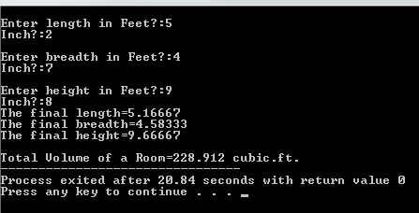

**Discussion & Conclusion:-**

The program is focused on various tasks on “Object As An Function Arguments”. From this program I understood how to pass and return object as an arguments & function call by one object passing second object as function arguments and return third object.

**Thank You**<SAKWheels>